Jeziel E. Torres Vazquez

INEL 4998 (Research)

Prof. Eduardo Ortiz

Week: February 8-12

Last week my task was to think and propose ways to make the coding faster and more efficient for when the Design Team gives us the new designs. For this task I started reading some of the Distribution System Impact Analysis research and papers. These papers were from the winning teams of the last competition. I specifically read the “Dartmouth College - Crystal Parks Distribution System Analysis”. I like the way they explain and defend the components, from a decision they took to make a better system for Dartmouth College.

First, they start talking about how they pick the irradiance and why this was important to the PV system. With this data the team can know for sure how many PV Arrays they specifically need for their current load. Then they talk about the lines and transformers and how they are recommended and upgraded because the current ones did not resist the amount of electricity. This will help the stability and performance of the system they were arming. They mention that the capacitor bank analysis was a good one but was not the way to go for their system. It was too expensive and the stability it gave to the system was already achieved by the transformer upgrade they made.

Angel Ortiz and I made a meeting to discuss the report he read “Florida University”. In the Florida report they had more graphs and a better analysis, in my opinion, to justify a battery. The use of REopt was a very easy way to explain and justify the need of a battery. It makes more sense to use a battery in their use case scenario. Here are some pictures of the report I read from “Dartmouth College - Crystal Parks Distribution System Analysis”:

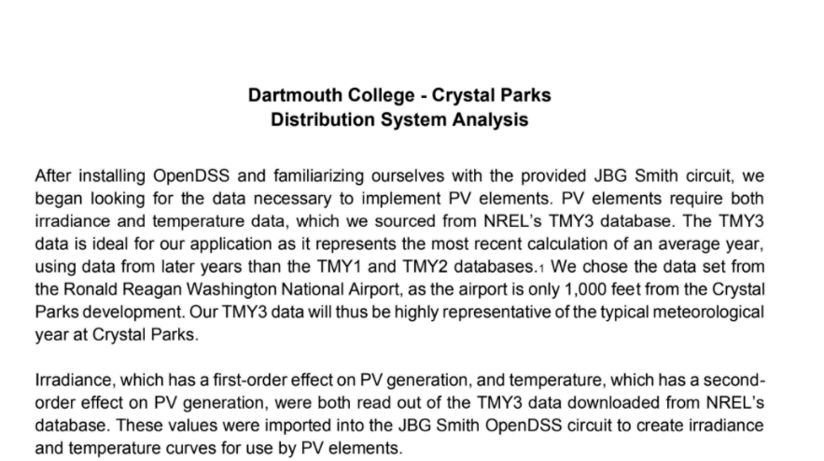

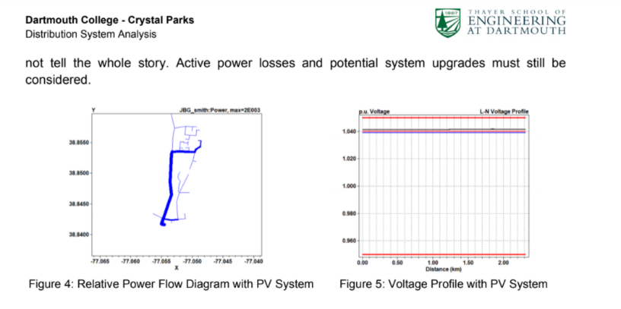

With the knowledge acquired in this reading I started thinking and analyzing ways to make more efficient our coding and analysis of the Distribution Impact Analysis. In the meeting I suggested that we could do a word document with all the important data and parameters that can be changed at any time without messing too much. This will improve the understanding of what we are really changing and not remembering what where the other parameters. Another thing that we could do is make important lines of code for the inverter and capacitor bank and when the parameters are ready, we just put them in the code, and everything is done. We do not have to start searching for information on how to make those lines or running into coding problems. For next week, the task that was given to me is to search and investigate what important parts of OpenDss like plots and graphs can be used to make the Distribution Impact Analysis. This will require search in the internet or in any documentation of the program to search for the perfect information for our analysis.